**Posture Assurance System User’s Manual**

Jeff Elliott, Zac Erba, Ryan Seale, Lindsey Watterson

May 6, 2015

# IMG_0118.JPG

Table of Contents

[Introduction 1](#_Toc418640707)

[Instructions 2](#_Toc418640708)

[Securing the PAS 2](#_Toc418640709)

[Powering on the Device 3](#_Toc418640710)

[Powering off the Device 4](#_Toc418640711)

[Changing Batteries 5](#_Toc418640712)

[Connecting to the Device 6](#_Toc418640713)

[Using the Device 7](#_Toc418640714)

[Routine Maintenance 8](#_Toc418640715)

[Charge Batteries 8](#_Toc418640716)

[Check Controller Connections 9](#_Toc418640717)

[Check Pad Sensors 11](#_Toc418640718)

[Check Support Straps 11](#_Toc418640719)

[Precautionary Information 12](#_Toc418640720)

[Troubleshooting 12](#_Toc418640721)

[Some LEDs Don’t Turn On 12](#_Toc418640722)

[Music Volume Does Not Change 12](#_Toc418640723)

[Device Does Not Show Up in Bluetooth List 12](#_Toc418640724)

# Introduction

The Posture Assurance System (PAS) is posture detection system that provides feedback to the user through the control of music volume. It was developed to help encourage wheelchair users to maintain good posture while in their chair and it was specific design for Drew Christy. Drew loves music and music has been used before during therapy to encourage him to maintain posture so music was used as the feedback in this system. The system rests on the back of a wheelchair or any high backed chair. It is placed with the cushioned pad towards the seat of the chair and the electrical housing box on the back of the chair. Once powered on the device connects through Bluetooth to Bluetooth compatible music player such as an iPhone or Android phone. Once a pair of headphones is connected to the headphone jack of the PAS the user will be able to hear the music through the device. Once the user sits in the chair the PAS automatically calibrates and sets the maximum volume allowed. As the user leans the volume of music will go down and then will increase again once the user has corrected their posture. This provides real time feedback every five seconds.

# Instructions

The instructions for performing the main activities necessary for using the PAS are listed below.

## Securing the PAS

See Figure 1 below for a demonstration of important steps. These figures demonstrate it being secured to a regular high backed chair but the same process is to be followed with wheelchairs and any other high backed chair.

1. Unbuckle any securing straps.
2. Drape the PAS over the back of the chair with the cushion located on the front of the chair and the electrical housing on the back of the chair.
3. Adjust the securing straps to allow for buckling to their respective buckle.
4. Buckle the straps.
5. Tighten the securing straps so that the PAS does not move.

1

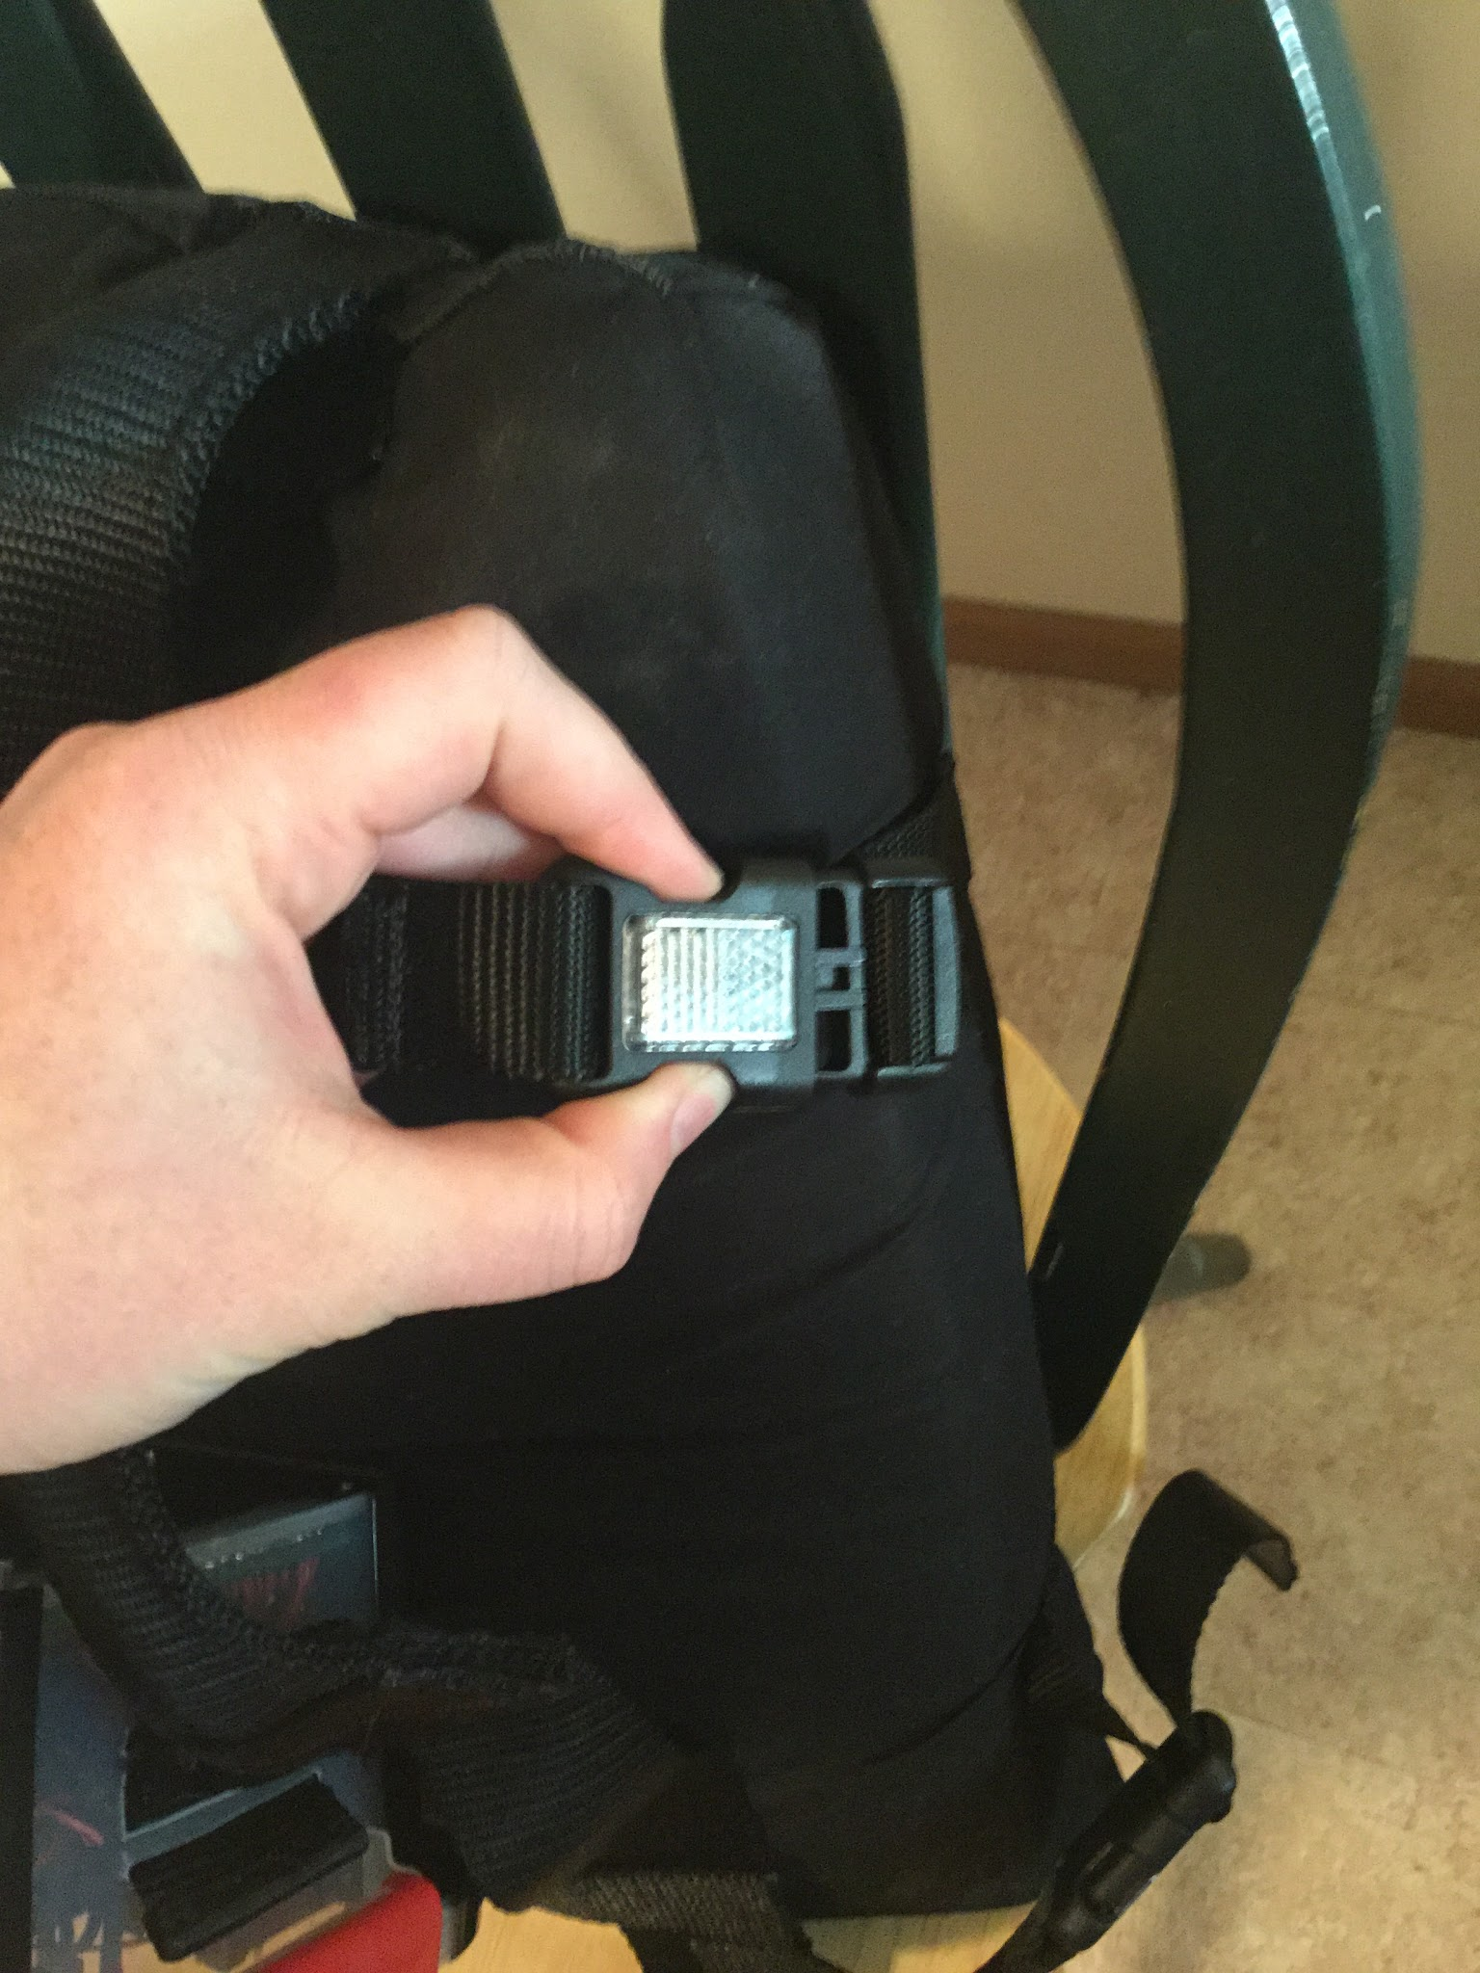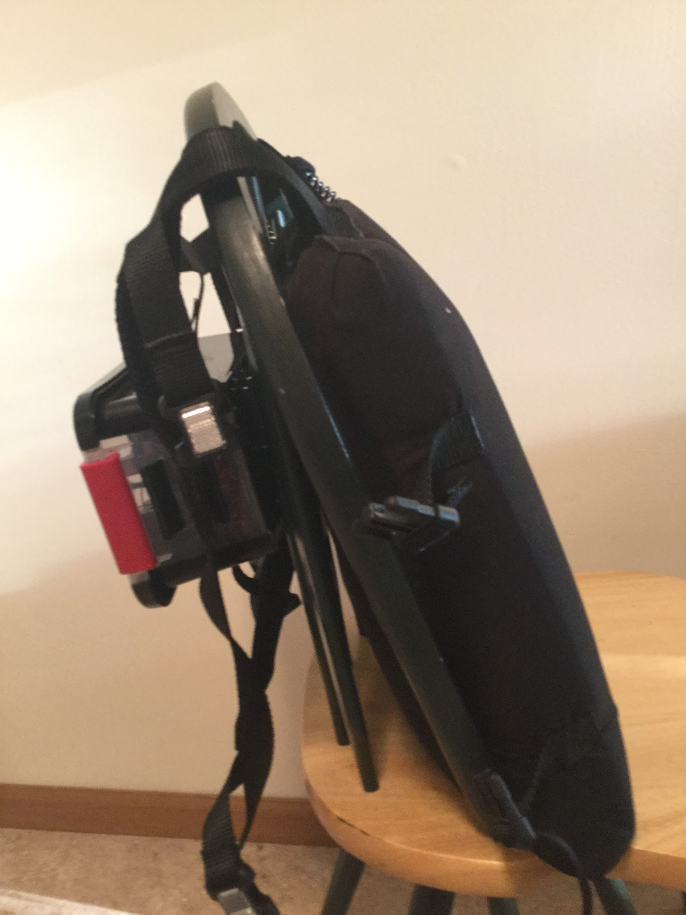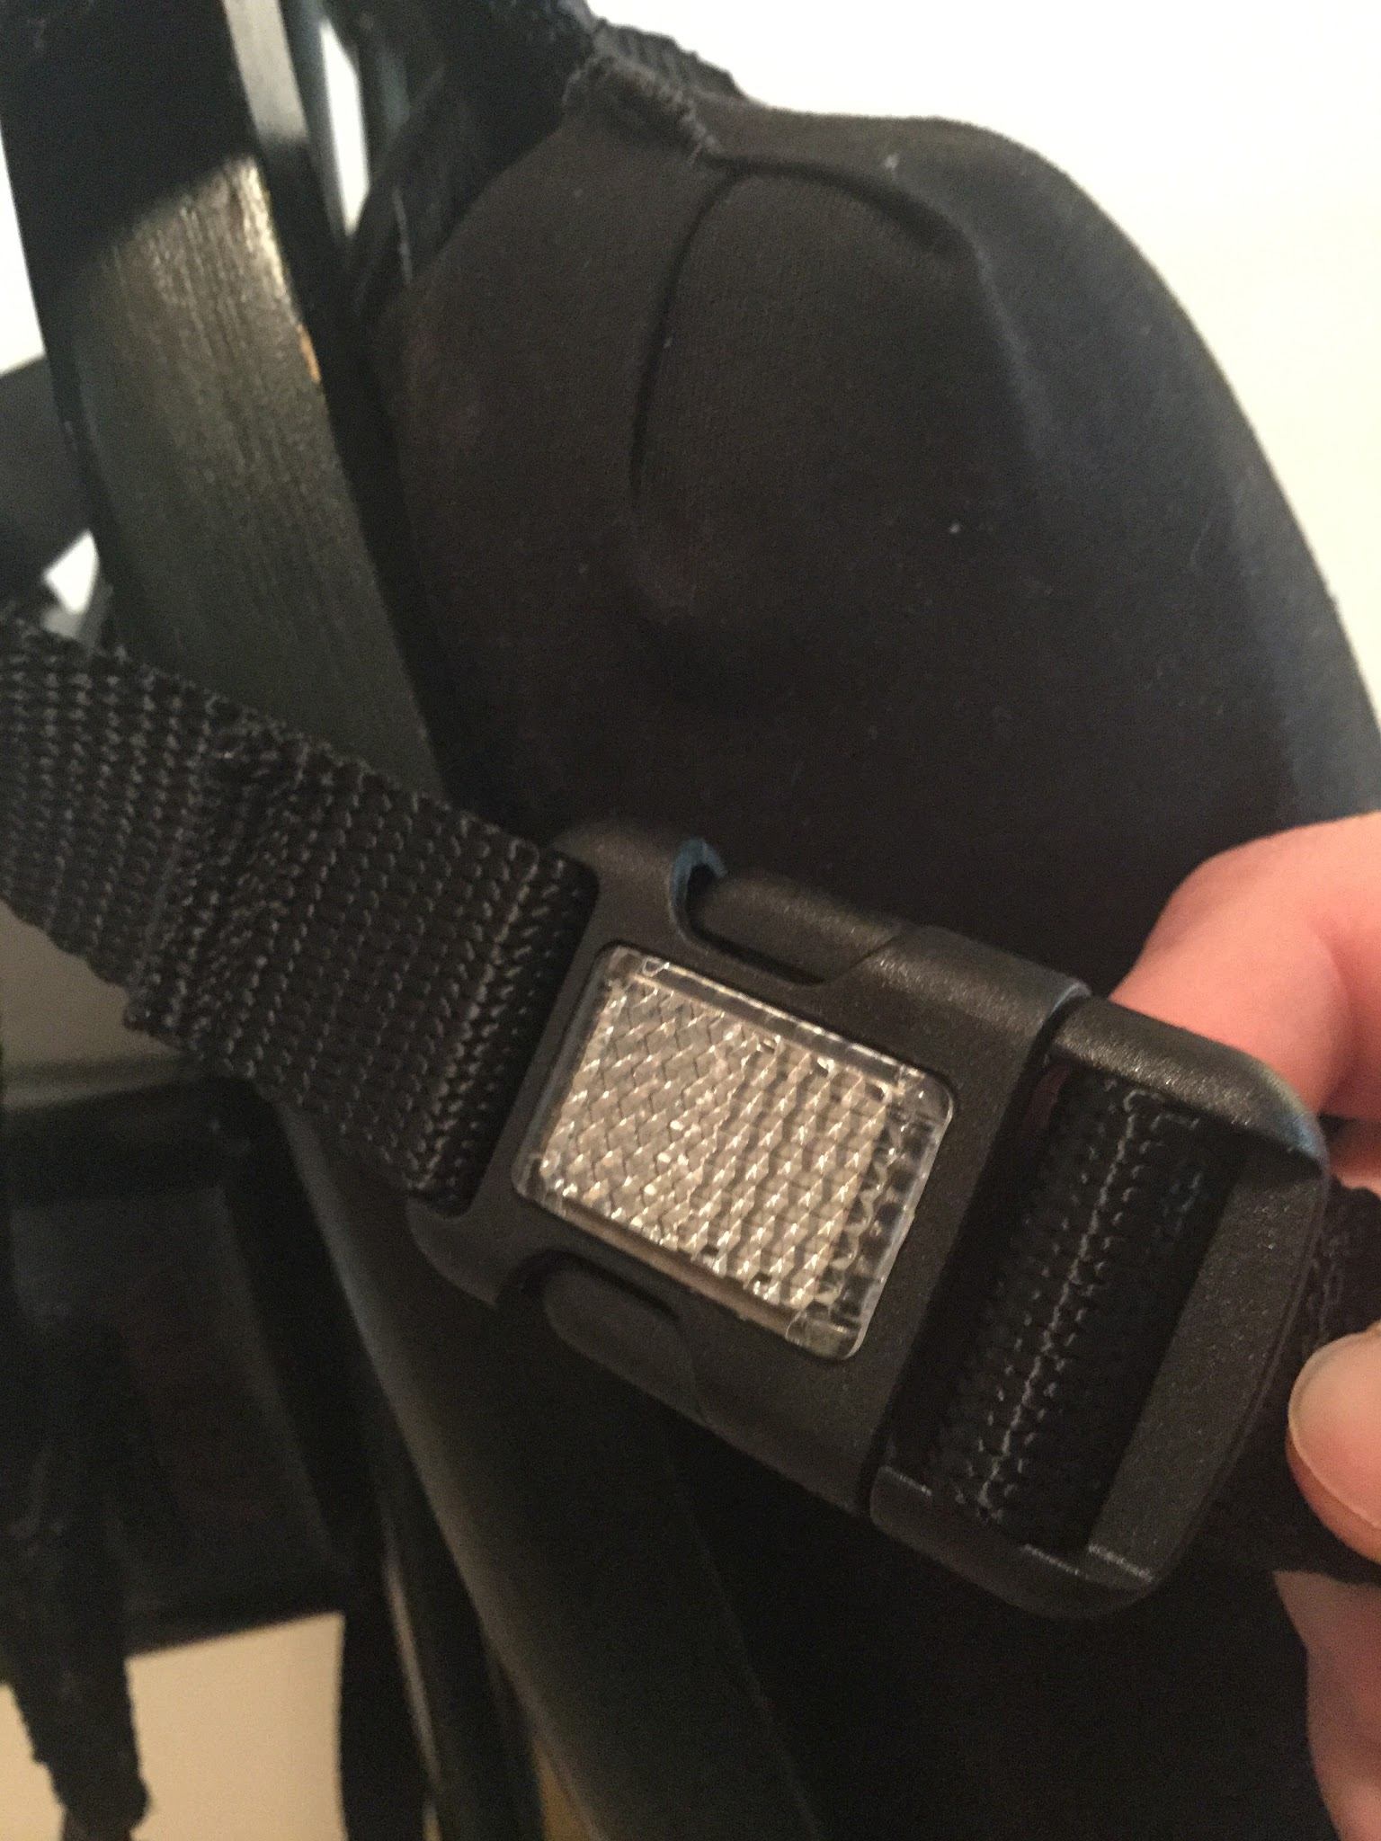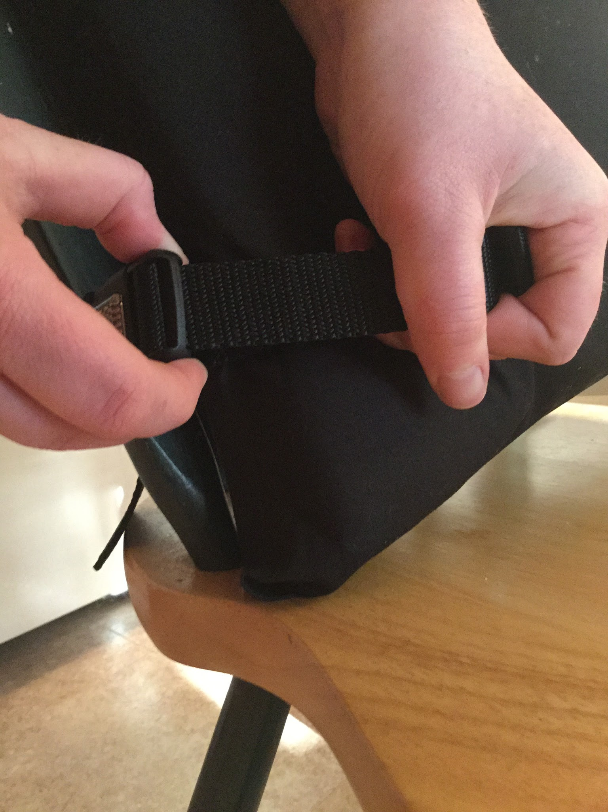

2

5

4

**Figure 1.** Above shows steps 1, 2, 4, and 5 of securing the PAS to a chair.

Powering on the Device

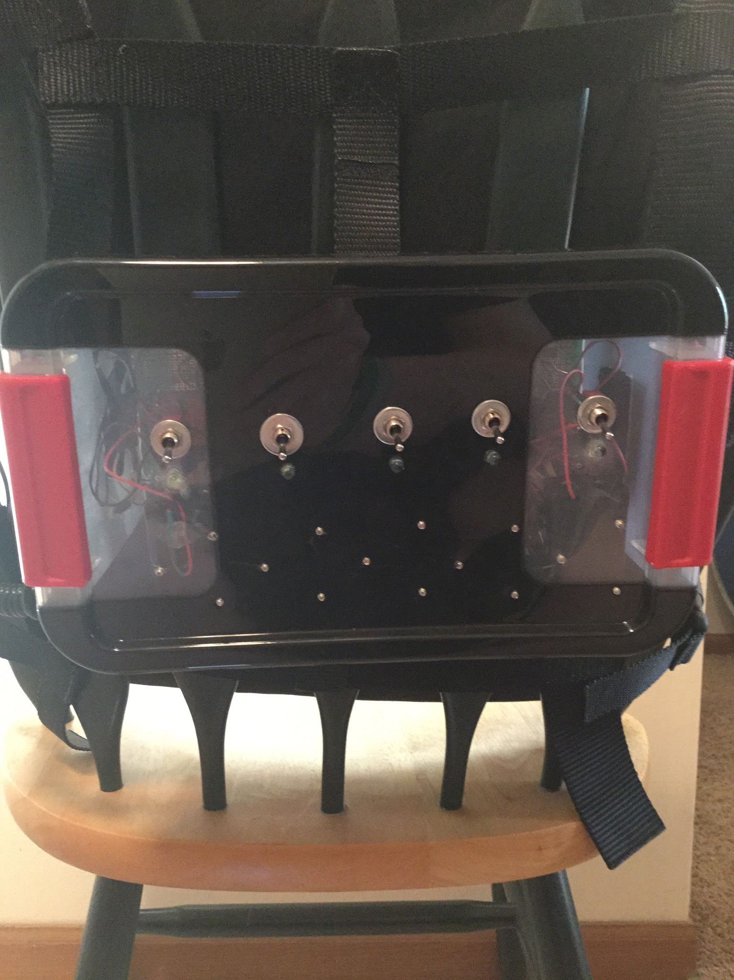

1

2

3

4

5

**Figure 2.** The switches on the electrical housing box and their corresponding numbers.

1. To power on the device locate the five switches on the front of the electrical housing box.
2. Flip each switch up from right to left.
3. Ensure all five LEDs are lit up.
   1. If an LED is not lit up, try flipping the switch again.
   2. If it still has not lit up, follow the steps for changing the batteries.

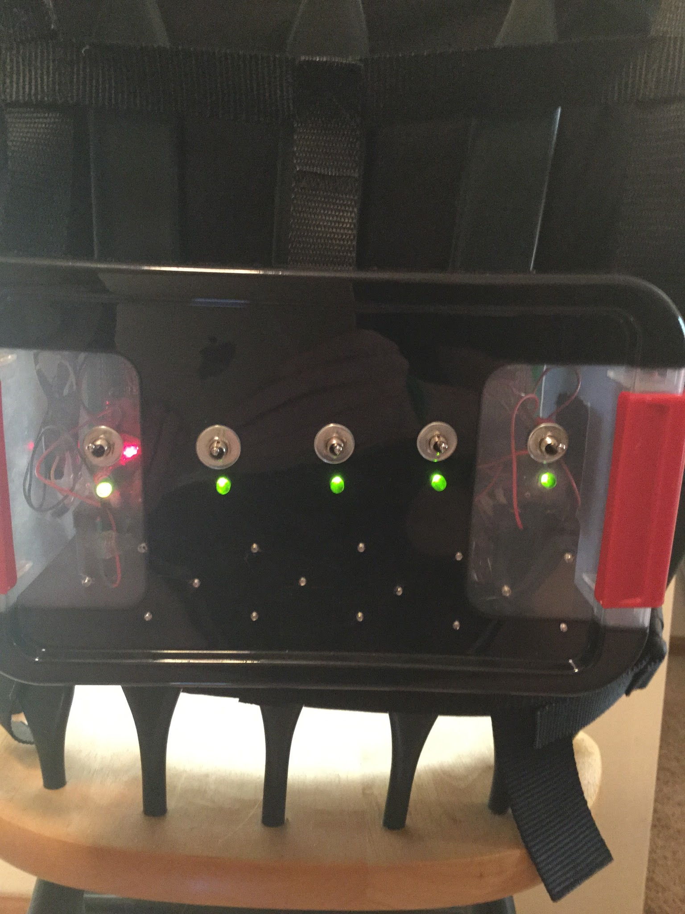

5

4

3

2

1

**Figure 3.** The result of step 3.

## Powering off the Device

Do this after each use of the device. It is also suggested to recharge the batteries after each use, especially batteries 1, 4, and 5 which correspond to the batteries under switch 1, 4, and 5.



5

4

3

2

1

**Figure 4.** The switches on the electrical housing box and their corresponding numbers.

1. Locate the five switches on the front of the electrical housing box.
2. Flip each switch down.
3. Ensure all LEDs are off.

## Changing Batteries

It is suggest to change or recharge the batteries after every use, especially batteries 1, 4, and 5.

1. To change the batteries, remove the PAS from any chair.
2. Lay it flat on a table.
3. Release the lid locks
4. Remove the lid of the electrical housing box and allow it to lay on or close to the table. (NOTE: DO NOT PULL ON THE LID OR FORCE IT TO LAY FLAT. THIS MAY RESULT IN WIRING DAMAGE AND MALFUNCTIONING OF THE DEVICE.)
5. Remove each battery from their holder and replace them with a fully charged battery

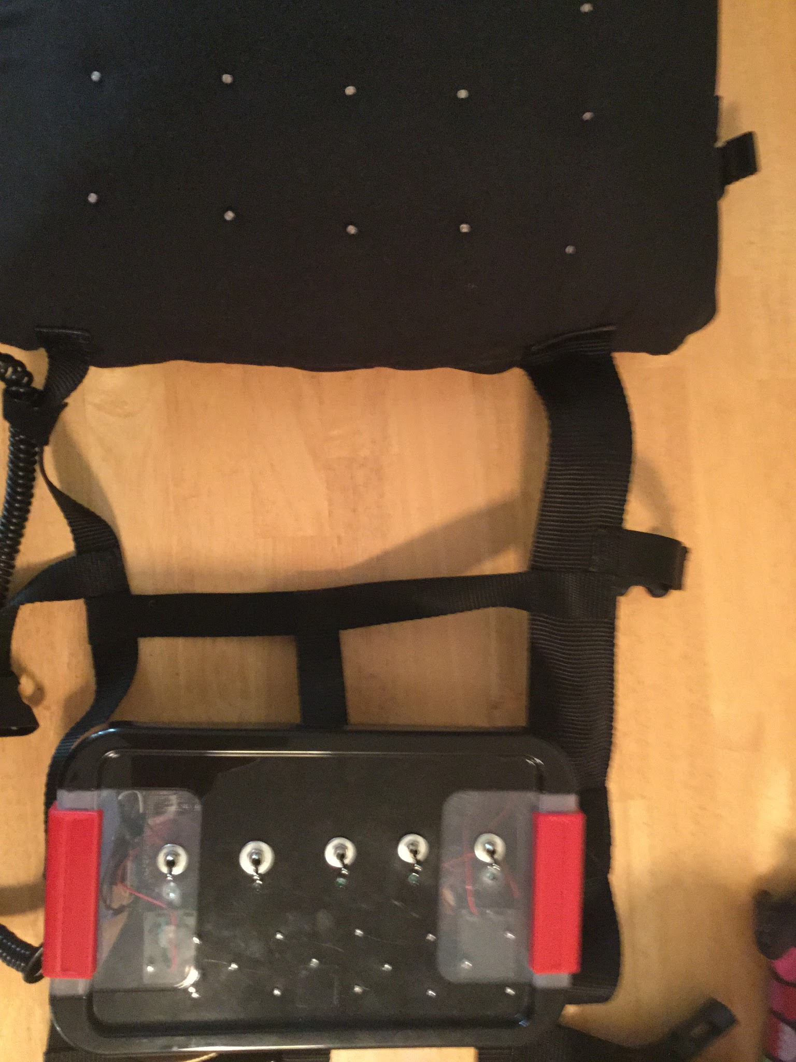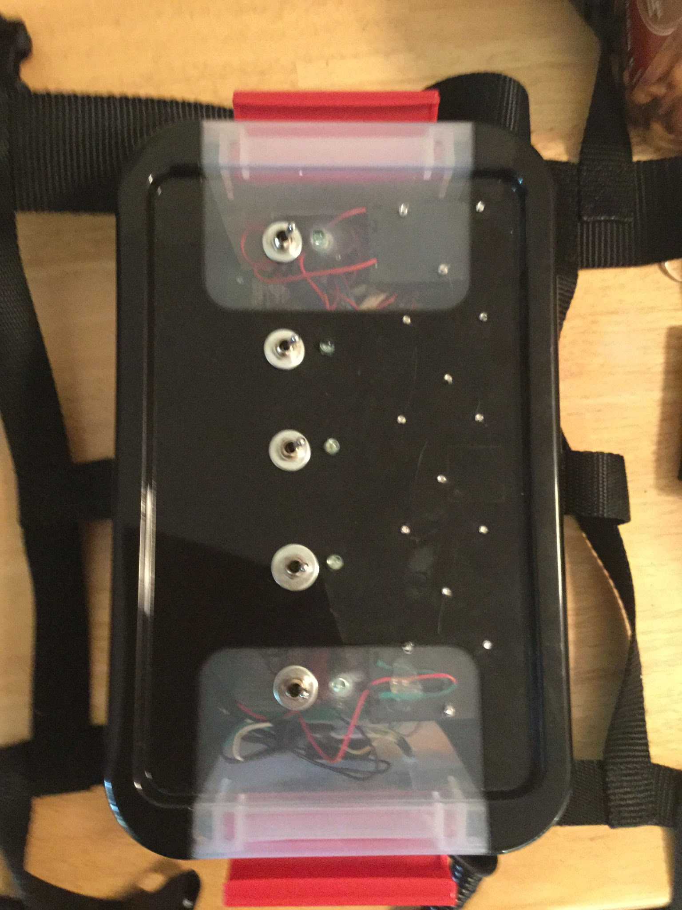

3

2

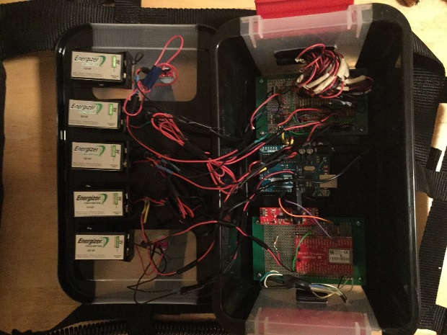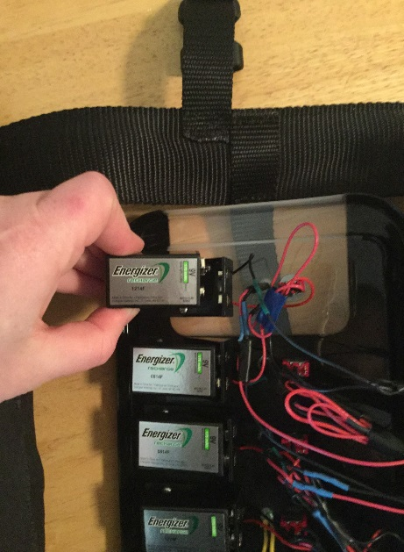

5

4

**Figure 5.** Steps 2 through 5 for changing the batteries.

## Connecting to the Device WITH A BLUETOOTH COMPATIBLE MUSIC PLAYER

This requires the device to first be powered on.

1. Power on the device.
2. Using your Bluetooth compatible music player, open you Bluetooth connection menu.
3. Allow the available Bluetooth connections to refresh.
4. Select the RN52-2A71 connection or the connection prefixed with RN52.
5. Allow the device to connect.

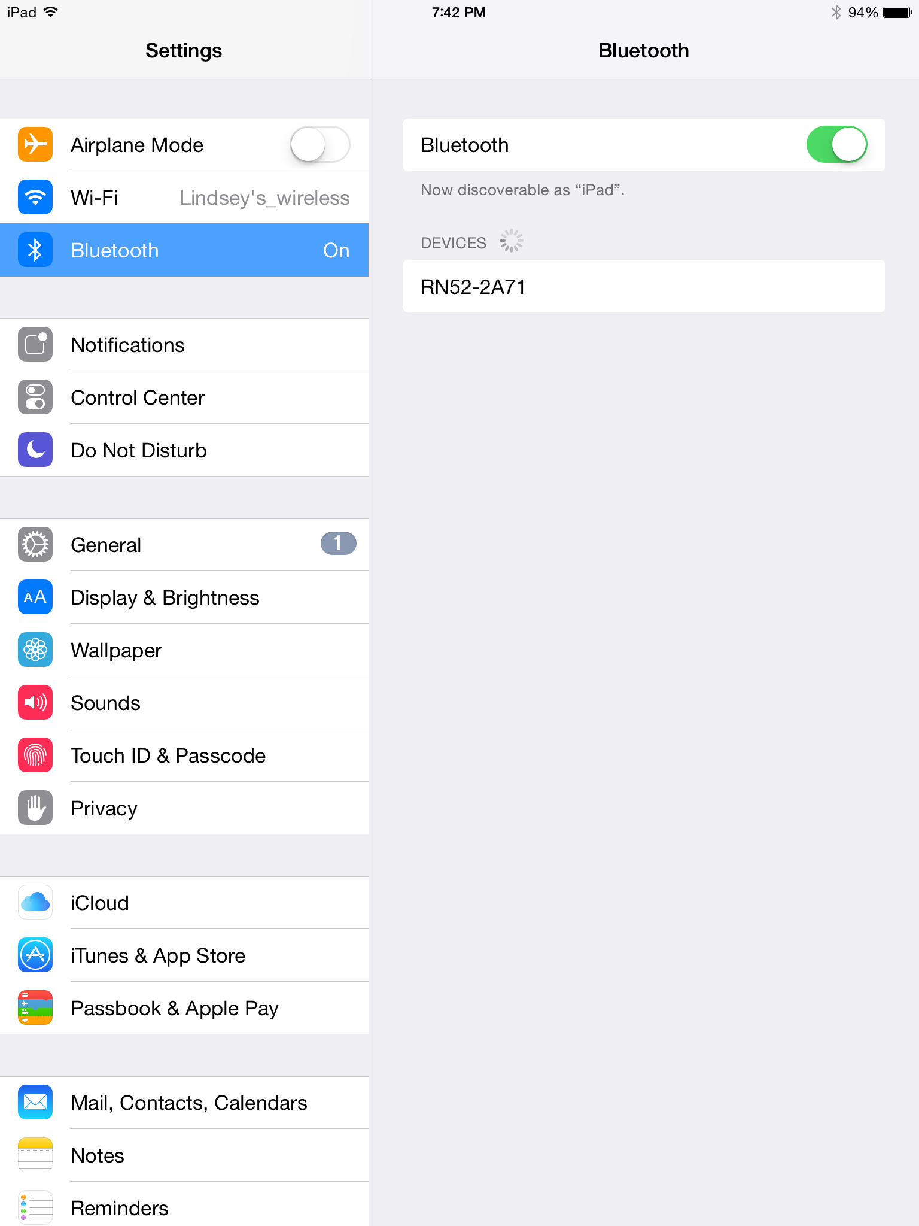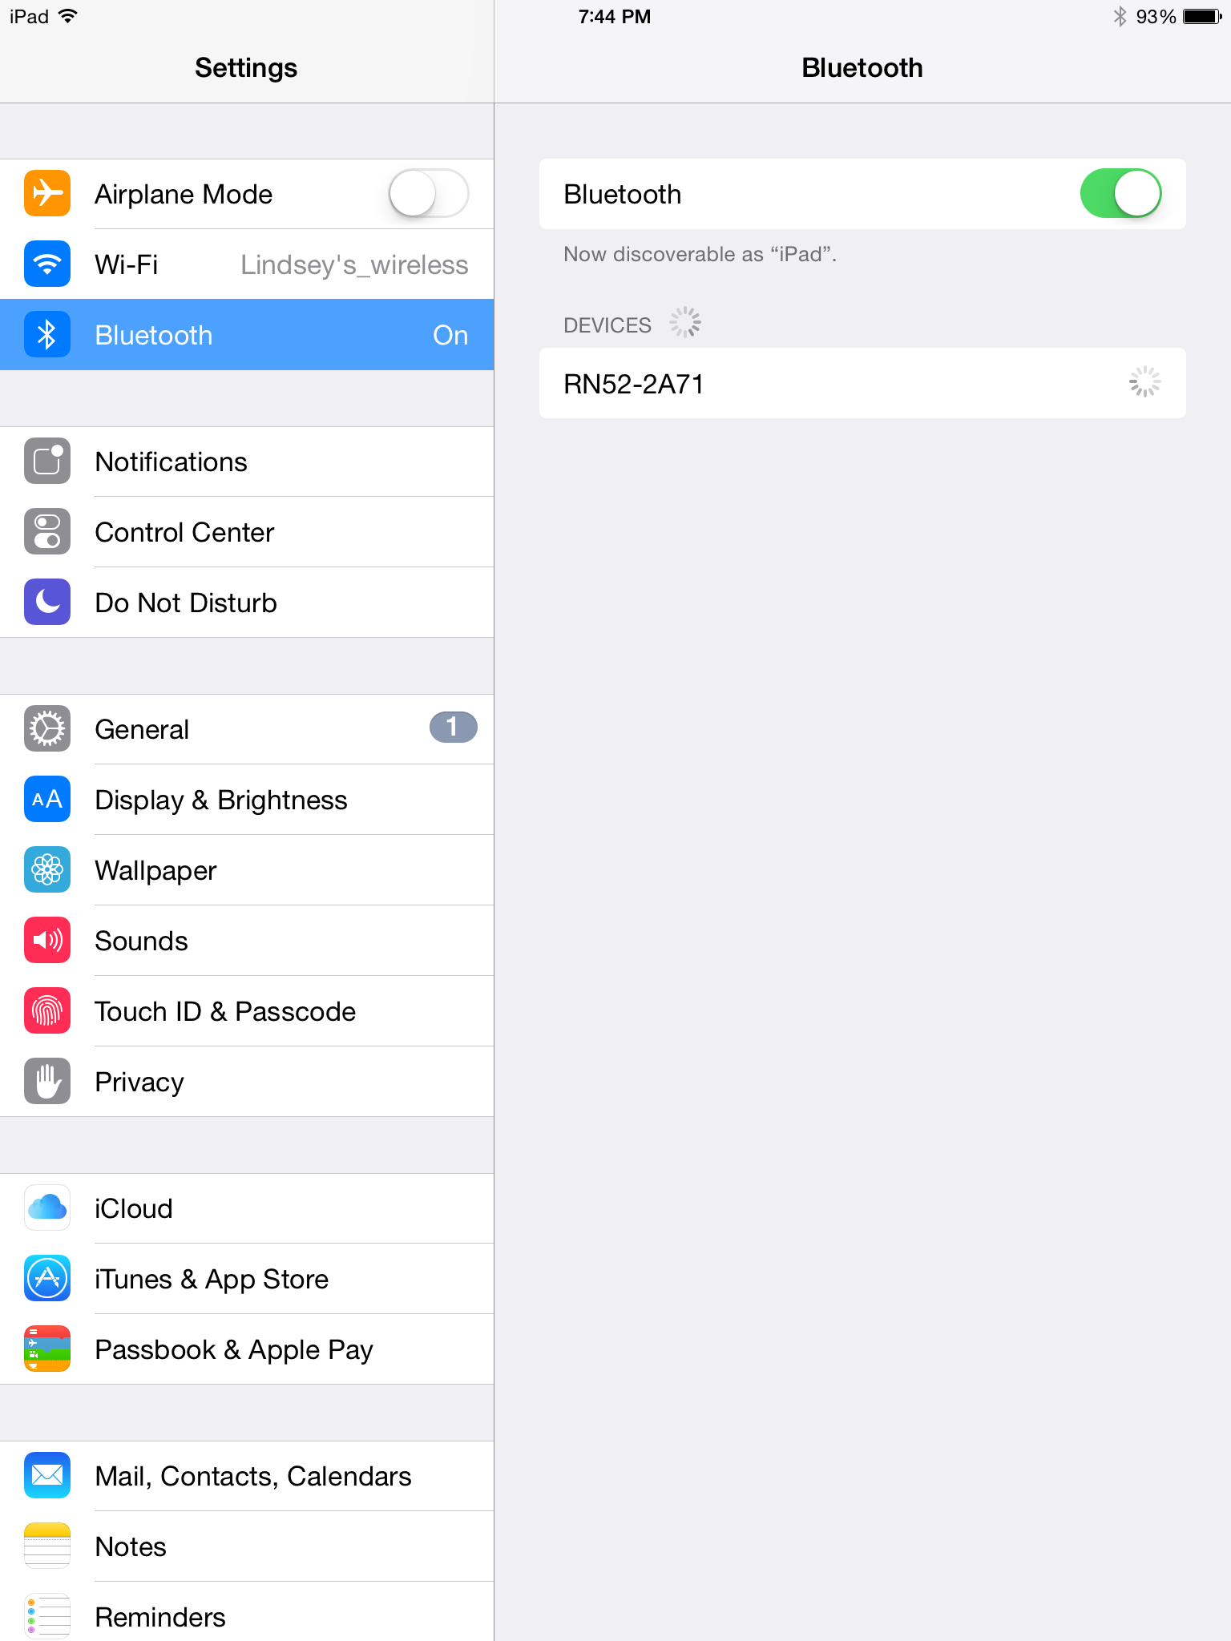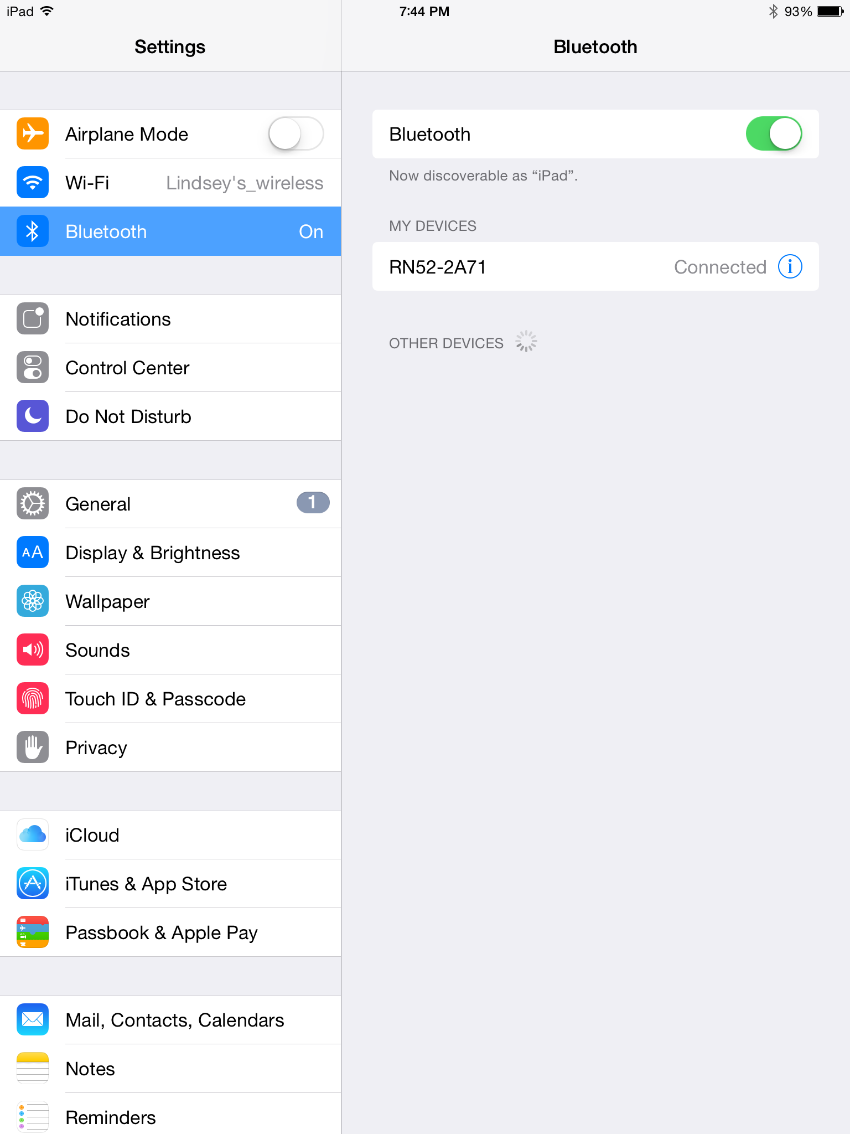

5

2-3

4

**Figure 6.** Steps 2 through 5 for connecting a Bluetooth compatible device to the PAS.

## Using the Device

1. Secure the PAS to a chair. (User can sit in the chair at any point after this.)
2. Power on the device.
   1. If the device does not power on completely (indicated by the LEDs), see the Troubleshooting section of this document.
3. Connect to the device.
4. Plug in a set of headphones into the headphone jack.

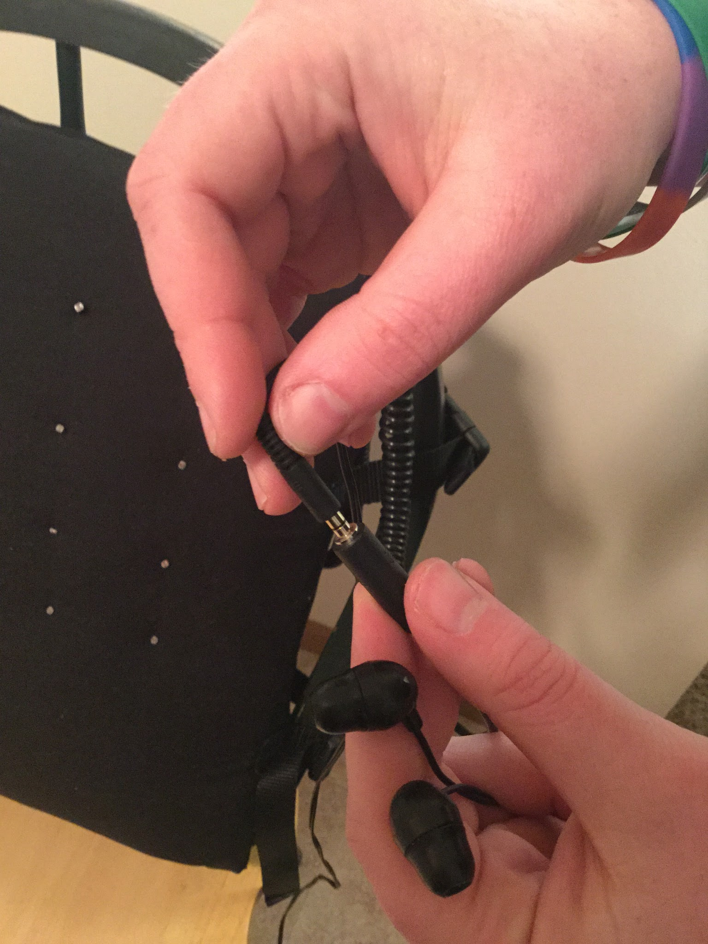

**Figure 7.** Step 4.

1. Start playing music on the Bluetooth enabled music player.
2. Check that you can hear music through the headphones.
   1. If you do not hear music, see the Troubleshooting section of this document.
3. Once done using the device, power it off.

# Routine Maintenance

Below is a list of tasks that should be done routinely:

1. Charge batteries
2. Check controller connections
3. Check pad sensors
4. Check all supporting straps for wear

## Charge Batteries

It is suggested that the batteries be removed from the device and charged after every use. At the very least the batteries for switch 1, 4, and 5 should be charged after every use. The batteries for switch 2 and 3 should be charge at the very least after 2 to 3 uses or after 15 hours of use.

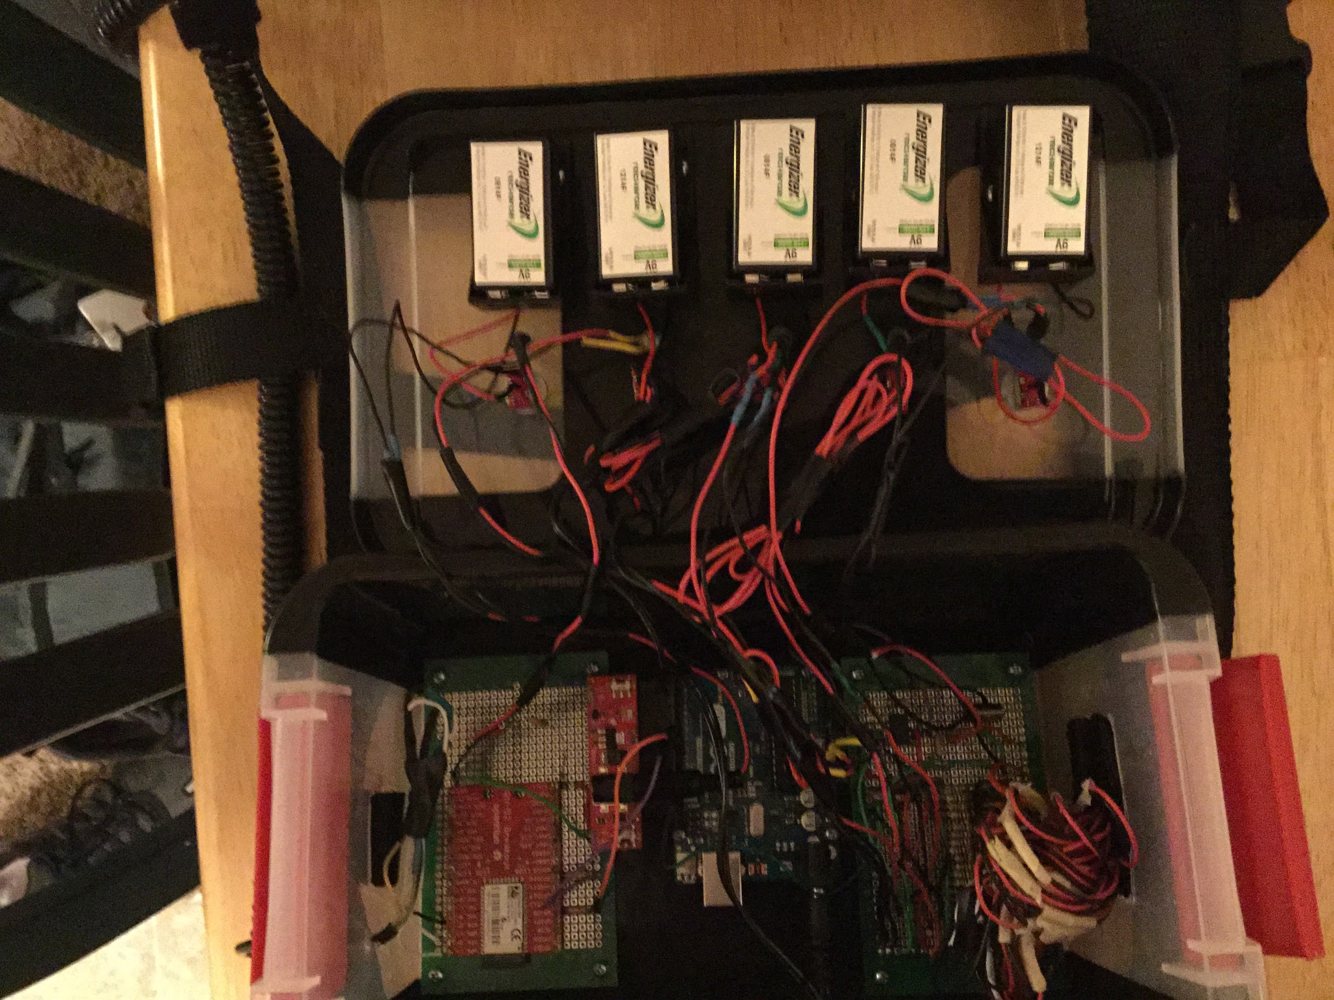

4

5

3

2

1

**Figure 8.** The batteries and their corresponding numbers. Batteries 1, 4, and 5 should be charged after every use.

## Check Controller Connections

During use a few of the wire connections can come loose. It is recommended to check these connections before each use since they will prevent the device from functioning if they are not connected.

The wires that will need checking are located within the circled area shown below and need to connect to the blue Arduino chip in the middle of the electrical housing box.

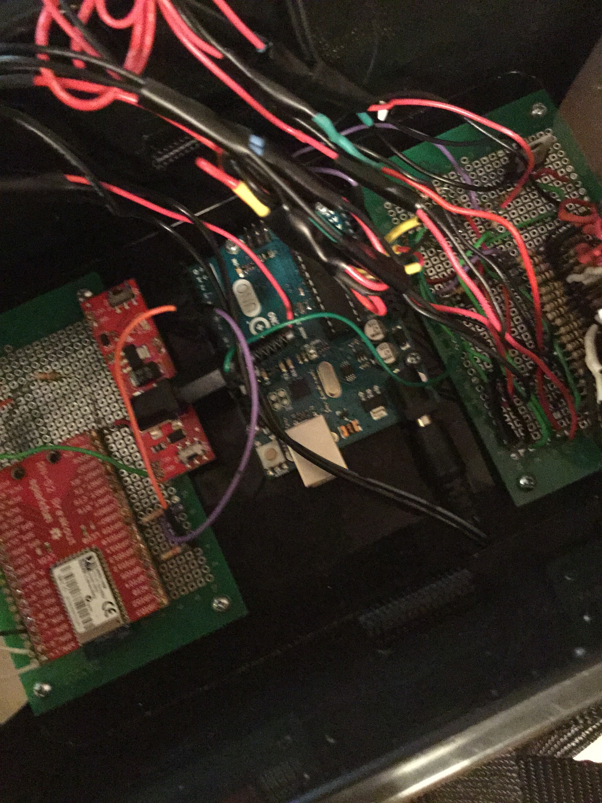

**Figure 9.** The location of the wires that need to be checked for loose connections. The location is circled in red.

Ensure that the purple wire is placed in the slot labeled 7 and the orange wire is in the slot labeled 8 as shown below.

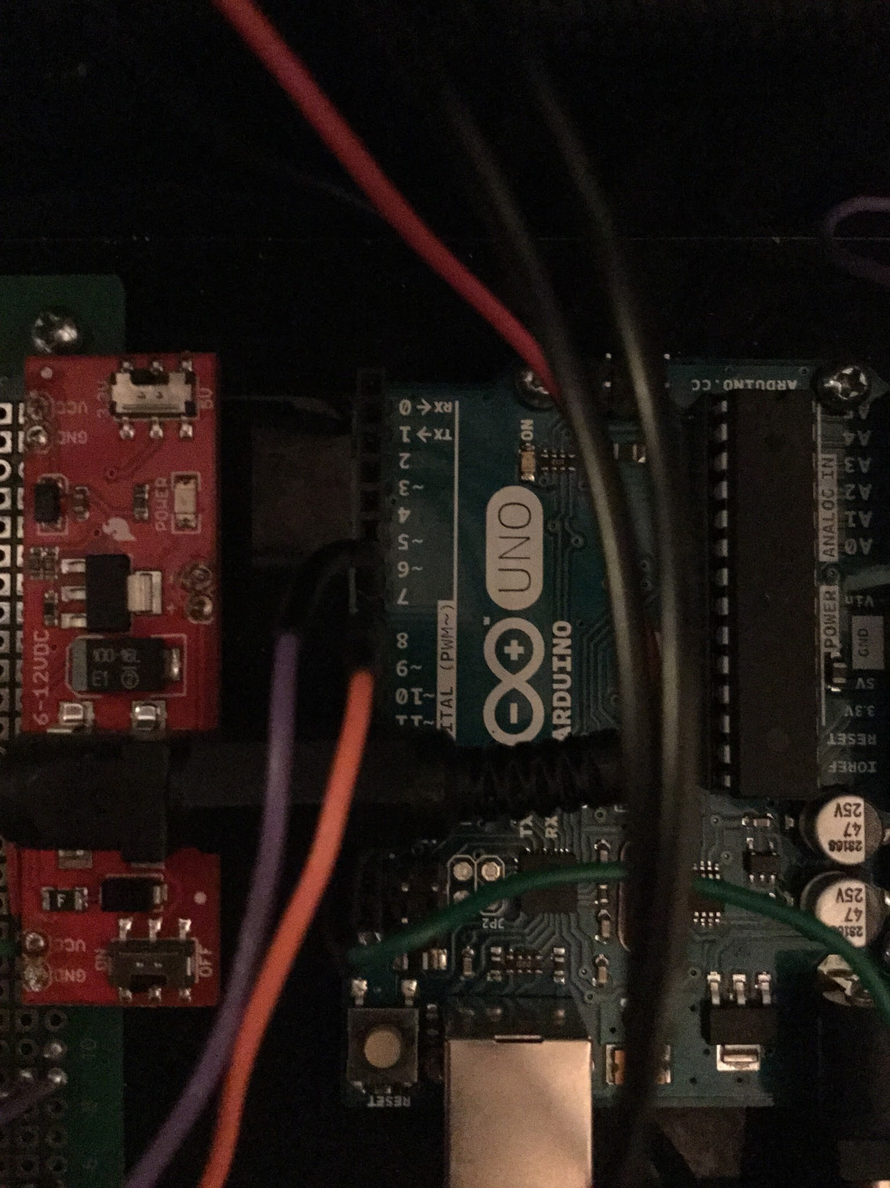

**Figure 10.** The location of the purple and orange wire. The red arrows point to their input location more directly.

Also ensure that the green wire is in the slot labeled GND as shown below. This wire can be more difficult to insert due to its location relative to the power plugin for the board beside it.

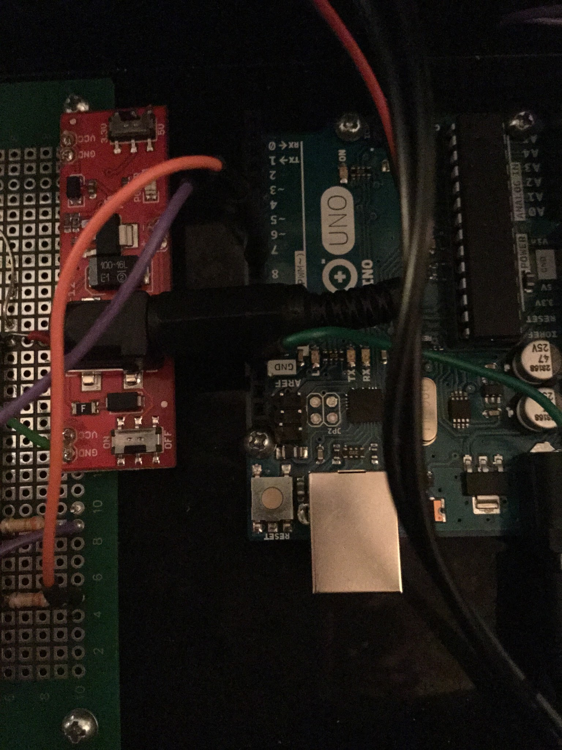

**Figure 11.** The location of the green wire. The red arrow points to its input location and the green arrow points out the green wire.

## Check Pad Sensors

After a couple of times of use, the sensors on the sensor pad need to be checked. This involves ensuring the sensors aren’t bent like shown below. If they are, straighten them out. This ensures that they function properly.

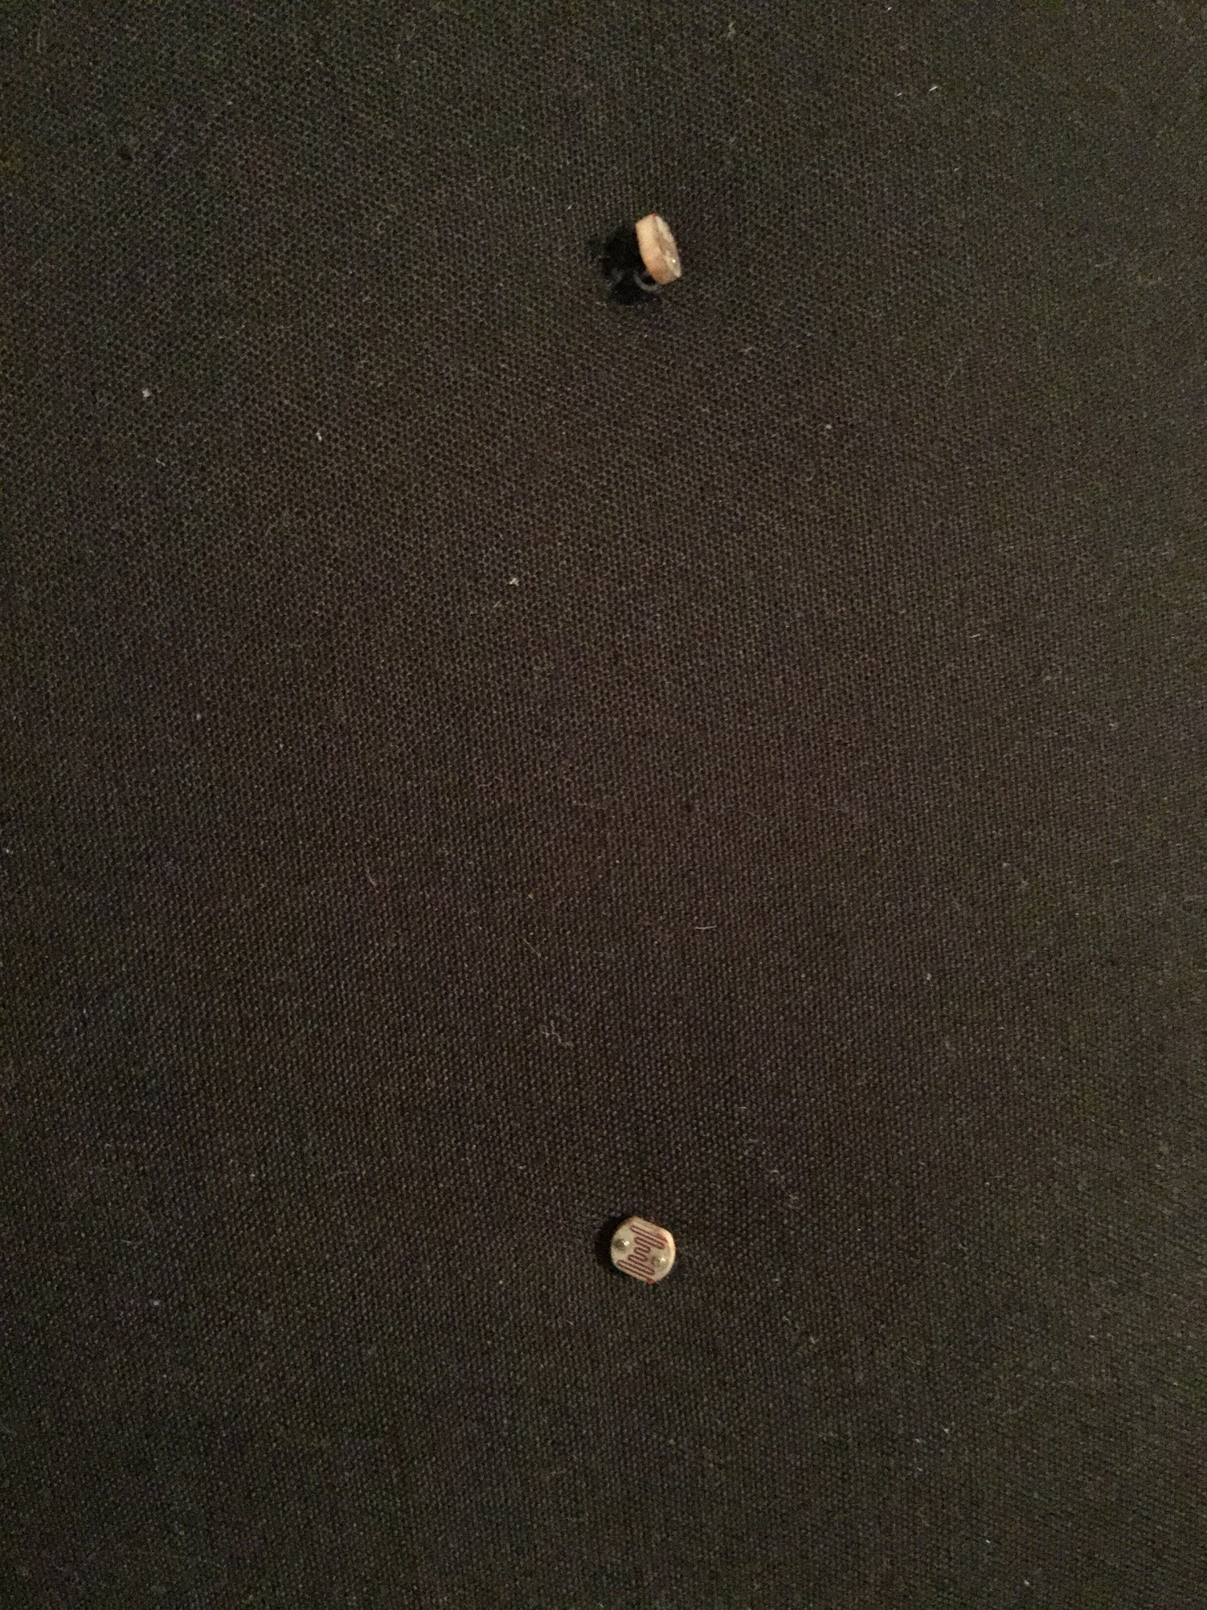

**Figure 12.** The sensor on the left shows a bent sensor while the one on the right is in the correct orientation.

## Check Support Straps

Every so often check the nylon straps to ensure they are still securely attached. If they are not secure, they can be re-sewn by hand or with a sewing machine. If sewing is required do not sew across the hollow section of the larger straps which contain the wires.

# Precautionary Information

Always ensure the device is securely fastened to the chair before use. There is a risk of it sliding off of the chair with the user if it is not fastened. While the device is not heavy, it could still cause damage if it falls off the chair.

Do not expose this device to water. It is not waterproof and water can damage the device. The device can be used outside as long as it is not raining.

Never open the electrical housing lid with the device powered on. While the device does not use enough power to deliver an unsafe shock, there is still a potential for shock while removing the batteries.

# Troubleshooting

Below are some basic scenarios that may occur while using the device and how to fix them.

## Some LEDs Don’t Turn On

While turning the device on if some of the LEDs turn on, first check that the switch is up. If it is then charge the batteries and ensure they are charged fully. If the device still does not turn on, contact Dr. Livesay or Dr. Rogge to perform maintenance.

## Music Volume Does Not Change

If you followed all the steps for using the device and cannot detect a change in volume when it should, turn the device completely off and then turn it back on and ensure all LEDs are lit. If the volume still does not change, follow the directions in Routine Maintenance for Check Controller Connections. If this still does not fix the problem, contact Dr. Livesay or Dr. Rogge to perform maintenance.

## Device Does Not Show Up in Bluetooth List

If the RN-52 does not show up in the list of Bluetooth devices, first turn off your music device’s Bluetooth and then turn it back on. If it still does not appear, turn off the Posture Assurance System completely and then turn it back on. Try connecting to it again and refresh the available connections. If this still does not fix it, contact Dr. Livesay or Dr. Rogge to perform maintenance.